**ST. Xavier's College**

**(Affiliated to Tribhuvan University)**

**Maitighar, Kathmandu**



**Assignment #09**

**Prepare a detail report on “Filling of Circle and Ellipse”**

**Course:**

**Computer Graphics**

# SUBMITTED BY

Aashish Raj Shrestha

Roll No: 013BSCIT002

BSc.CSIT, 4th semester

**SUBMITTED TO**

**Er. Anil Sah**

**Lecturer**

Department of Computer Science

St.Xavier’s College

Maitighar, Kathmandu

STATEMENT:

Perform Shearing Transformation

ALGORITHM:

1. Start
2. Assign x, y, hx, hy, shx, shy.
3. Take values for x, y, hx, hy.
4. Compute:

shx = x + hx . y

shy = x . hy + y

1. Use Matrix

1. Terminate

SOURCE CODE:

//---------------------------------------------------------------------------

#include <vcl\vcl.h>

#pragma hdrstop

#include “Shear.h”

//---------------------------------------------------------------------------

#pragma resource “*.dfm”

TForm1 *Form1;

int x,y, hx,hy;

//---------------------------------------------------------------------------

__fastcall Tform1::Tform1(Tcomponent* Owner)

: Tform(Owner)

{

}

//---------------------------------------------------------------------------

void __fastcall Tform1::SEARClick(Tobject *Sender)

{

x=Image1->Width;

y=Image1->Height;

hx = Edit3->Text.ToInt();

hy = Edit4->Text.ToInt();

for(int i=x; i>=0; i--)

{

for(int j=y; j>=0; j--)

{

int shx= i+(hx*j);

int shy=(hy*i)+j;

Image2->Canvas->Pixels[shx][shy]=Image1->Canvas->Pixels[i][j];

}

}

}

//---------------------------------------------------------------------------

OUTPUT:

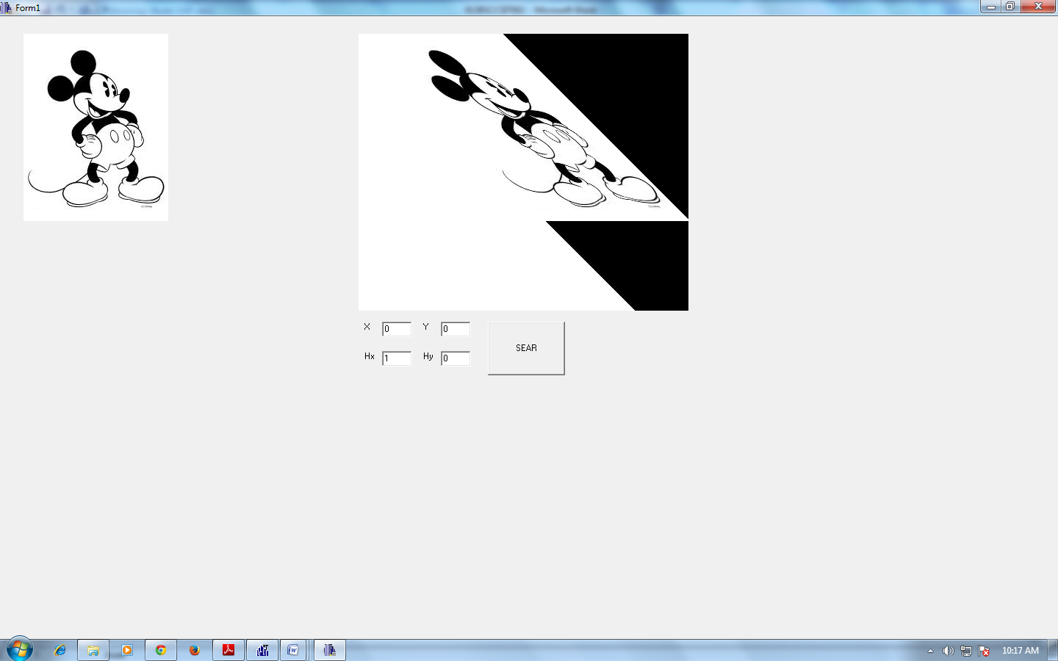

*Figure I: Shearing With Respect to Y Axis*

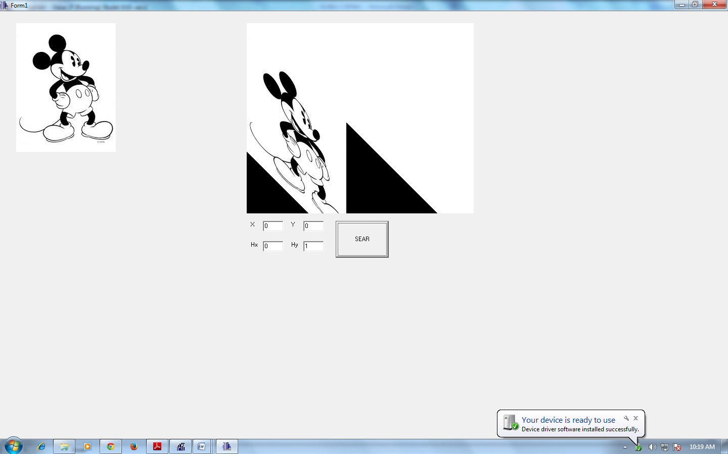

*Figure II: Shearing With Respect to X Axis*

CONCLUSION:

Hence, Shearing Operation was performed using C++ Builder.